Computer networks

**Lab activity – 8**

**Name :** N.V.M.Sumanth

**Reg no :** 192111449

**Faculty :** Dr. S. Ramesh

**Course code :** CSA0786 computer networks for wanet applications

**Lab activity : 8**

**Question - Subnetting – Class C Addressing**

**Step 1 : take a router**

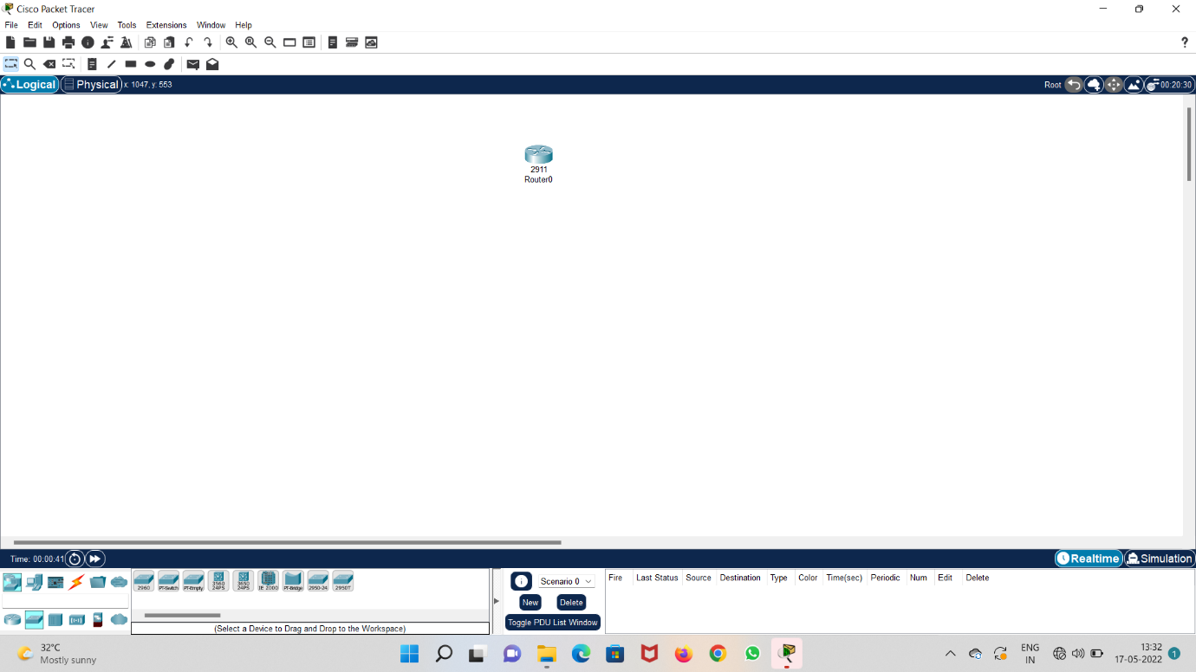

**Step 2 : take 2 switches and 6 systems and connect all**

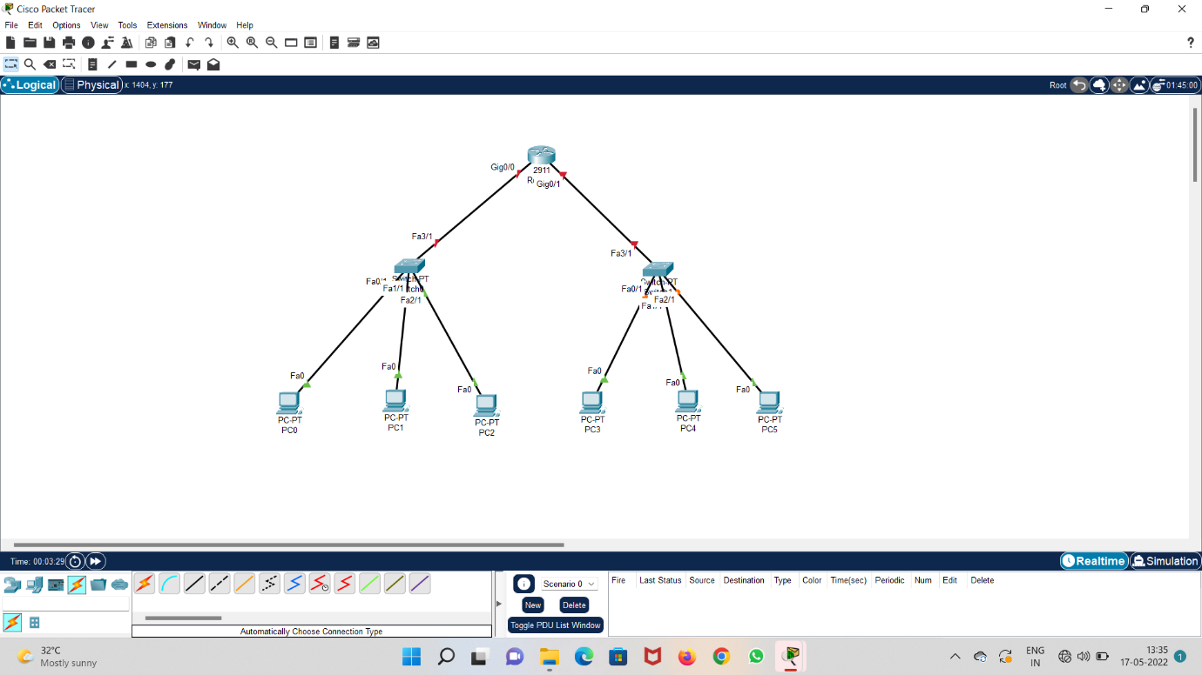

**Step 3 : configure IP address to all the systems**

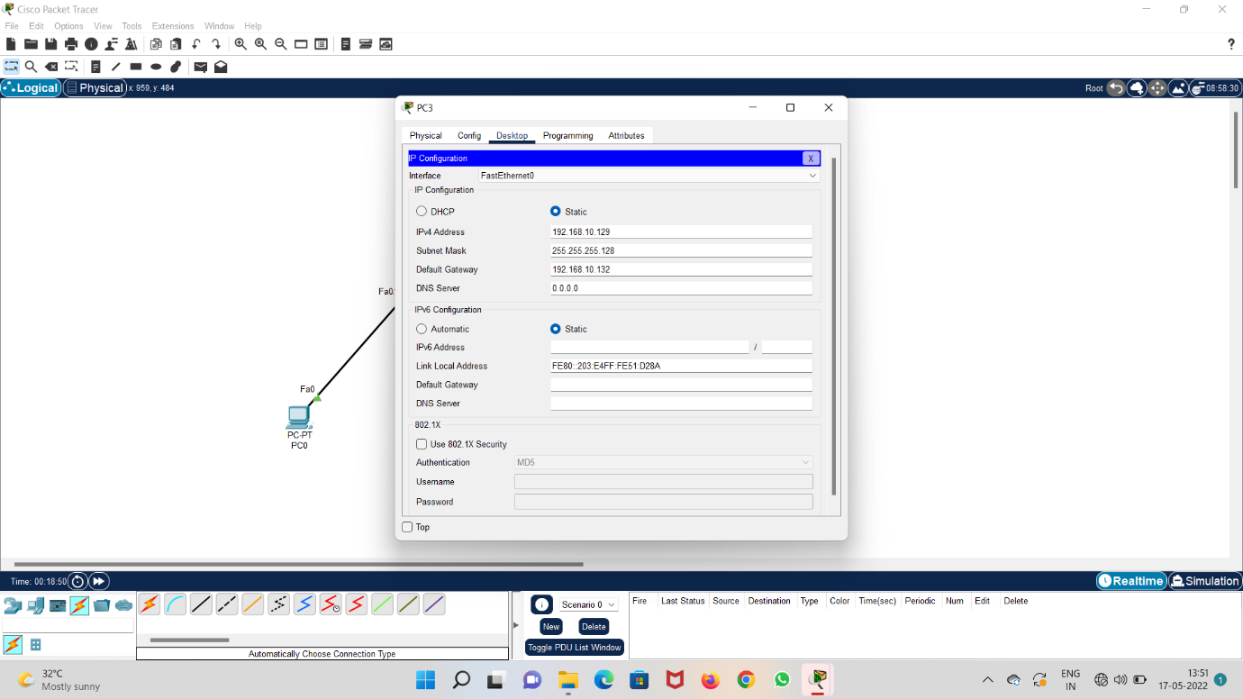

**Step 4 : configure IP address and switch on the port in fast ethernet 0/0**

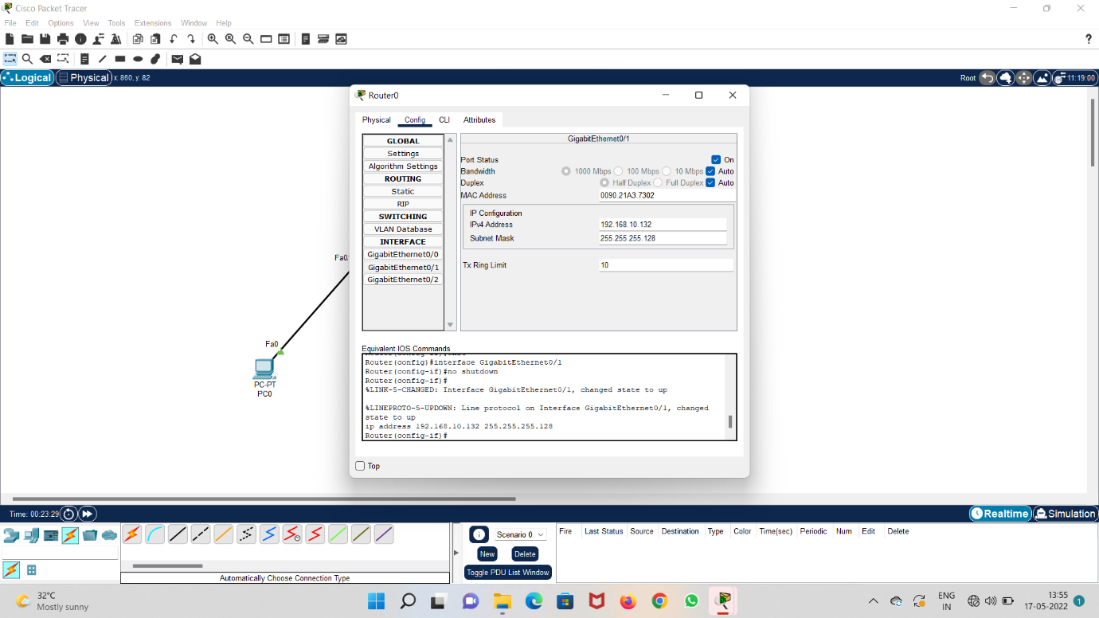

**Step 5 : configure IP address and switch on the port in fast ethernet 0/1**

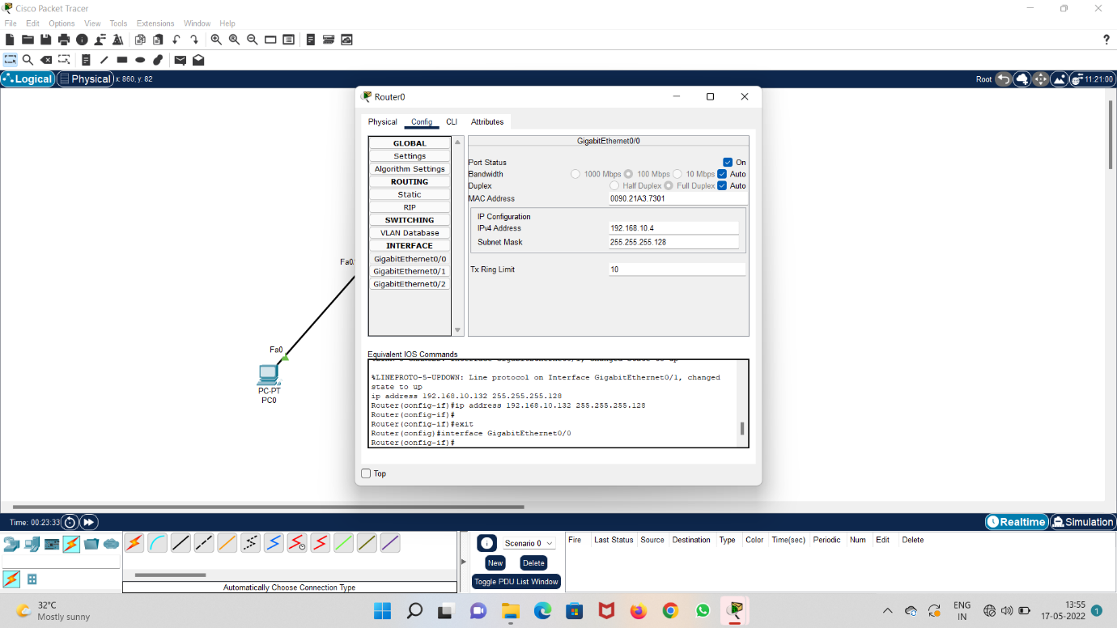

**Step 6 : ping Ip address 152.140.10.131 in pc 0**

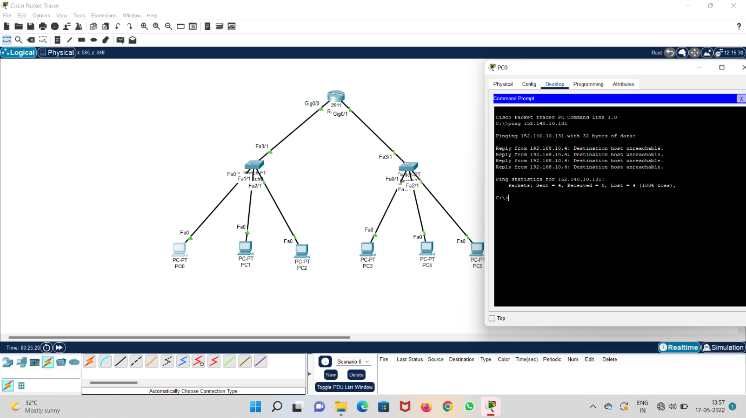

**Step 7 : run the system and check acknowledgement**

